HYDRAPOWER INSTALLS 10’ X3/4’ SHEAR AND 400 TON X12’ PRESS BRAKE AT STONE BRIDGE IRON & STEEL GANSEVORT, NEW YORK

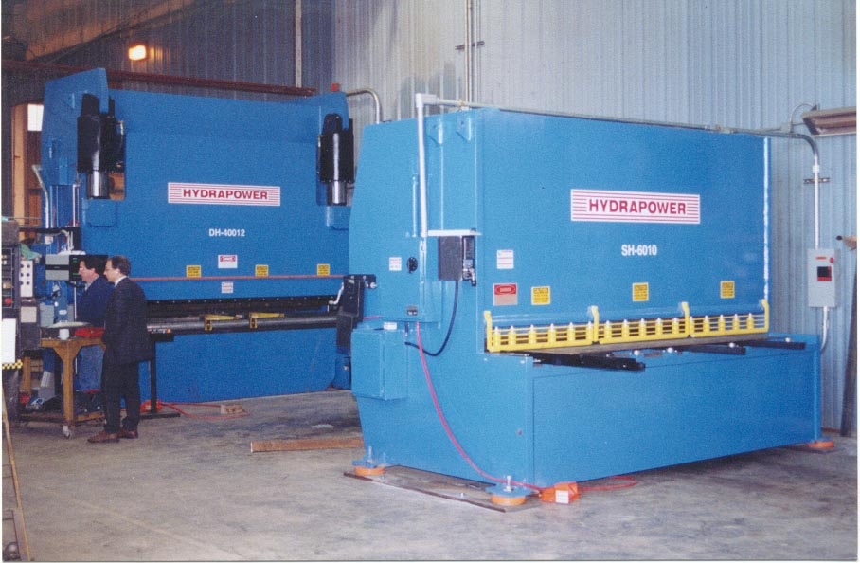

WE HAVE 2 HYDRAPOWER MACHINES IN OUR PLANT AND WE
ARE PLEASED WITH THEIR PERFORMANCE. THEY HAVE BEEN
RELIABLE AND FACTORY SUPPORT AND TRAINING HAS BEEN
OUTSTANDING.

LENNY SQUIRES, PRODUCTION MANAGER.

